*Array :*

storing multiple values in the single variable.used as a collection of data into a single variable.to use values efficient and not assing declare and initialize separate value which is time taking process.

Syntax:

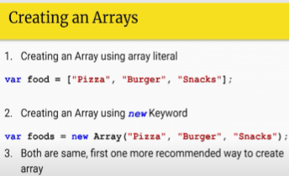

var array=[45,33,12,44,11]; //range 0 to -1

var menu=["sandwich","pizza","french fries","burger"];

var bools=[true,false,true,true,false];

var mixed=["hello",45.2,"#"];

var mixed2=[{sequnce : "mike"},{force : "afterwards 56 "}];

console.log(array[2]);  // accessing array elements

console.log(menu);

console.log(bools[3]);

console.log(mixed.length);

console.log(mixed2[1]);

console.log(mixed2[3]);  // undefined since the value is not at the given index

// add update elements using index

var adding=[];

adding[0]="a";

adding[1]="e";

adding[2]="i";

adding[3]="o";

console.log(adding);  // all arrays can printed

console.log(adding=>2);

console.log(adding[6]); // undefined

adding[11]="se";

console.log(adding+" "+adding.length);  // directly adding value jumping empty indexes.

//updating an

adding[2]="rt";

console.log(adding);

***push function***

lets you add array in an sequence not loosing or jumping out an empty index.

// array push

var pushing=[];

pushing.push(31);

pushing.push("hexadecimal");

pushing.push("somewhat","exactly");

console.log(pushing);

//array user input , order shop

var order=prompt("what do you want sir select category drink or  meal ");

var i;

var drink_cost=32;

var meal_cost=78;

var items_purchased=[];

var howmany=parseInt(prompt("enter quantity"));

switch(order){

    case "drink":

        total_paybill=drink_cost*howmany;

        console.log("your paybill is : "+total_paybill+" each costs : "+drink_cost+"$");

        break;

        case "meal":

            total_paybill=meal_cost*howmany;

            console.log("your paybill is : "+total_paybill+" each costs : "+meal_cost+"$");

            break;

}

items_purchased.push(order);

console.log(items_purchased+"of total quantity :"+howmany);

***array with loops:***

// check a value present in an array or not  searching a number

var arrayy=[54,44,28,4,6,2,1,3,6,47];

var searchnum=parseInt(prompt("Enter a number to check "));

var found=false;

for(var f=0;f<arrayy.length;f++){

    if(arrayy[f]===searchnum){

        console.log("entered number : "+searchnum+" found at index : "+f);

        found=true;

        break;

    }

}

if(found==false){

    console.log("your entered value is not found !");

}

cityToCheck = cityToCheck.toLowerCase();

Adding element into the middle of the array either to move the already present element so on or to remove an element.

***Other Array functions :***

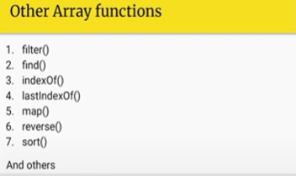

var num=[12,1,55,05,65,33,14,0,17];

console.log(num);

num=num.sort();

console.log(num);  //  [0, 1, 12, 14, 17, 33, 5, 55, 65]

console.log(num.reverse());  // [65, 55, 5, 33, 17, 14, 12, 1, 0]

***escape characters:***

not interprate an string complemtion but skip the part and consider further parts.

There are also scape characters like /t,/n,/s

***Functions Indexof and lastindexof:***

last index of starts finding value from descending order.

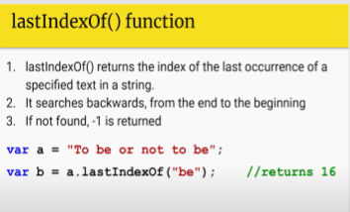

var cities="to be or not to be honest";

console.log(cities.indexOf("to",4));  //  13t index found "to"

console.log(cities.lastIndexOf("be",7));  //  3rd index found "be"

***char at and replace function:***

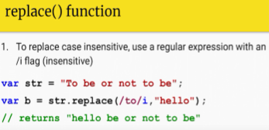**

**Replacing all values as value to be replace where-else found:**

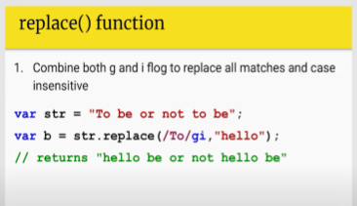

var cities="karachi";

console.log(cities);  // karachi  peshawar islamamabad nawabshah

console.log(cities.charAt(2));

var hay="glad to se you to se at the glad";

console.log(hay.replace("to","for")); //glad to se you to se at the glad

console.log(hay.replace(/glad/gi,"hello")); // replace where it  find glade in the particular string

***splits function***

return values of string into converted array value :

var valued="here ,we, go || again, to, the * same, way";

var a,b,c;

a=valued.split(",");

b=valued.split("||");

c=valued.split("*");

console.log(a); // ['here ', 'we', ' go', ' again', ' to', ' the', ' same', ' way']

console.log(b); //  ['here ,we, go ', ' again, to, the * same, way']

console.log(c); // ['here ,we, go || again, to, the ', ' same, way']

***Slice function :***

Seprates the part of string from a single value as we want.

Slice in string :

var enteramonth=prompt("enter a month");

var firstchar=enteramonth.slice(0,1);

alert(firstchar); // prints first character from string just

var rest=enteramonth.slice(1);

alert(rest); // prints rest of the character except first character of  string

var add=firstchar+rest; // concatenate both spliced strings

alert(add);

example 02

var enter=prompt("enter a month");

var check=true;

for(var i=0;i<enter.length;i++){

    if(enter.slice(i,i+1)===" "){

        alert("the string contains double spaces");

        check=false;

        break;

    }

}

if(check===true)

alert("no spaces in string found !");

***Array maps :***

maps hold key value pairs where keys are of any datatypes.

Map remembers original insertion of order of keys.

Some essential map methods are as follows :

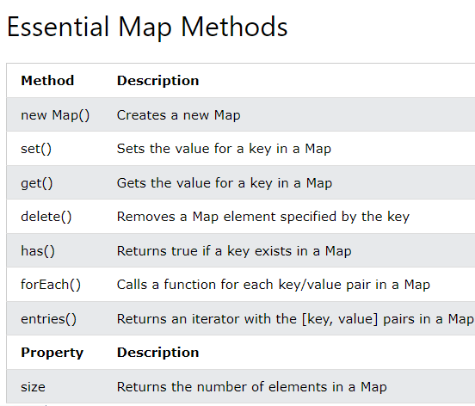

Create a map :

Passing array to new map();

Create a map and use it through map.set().

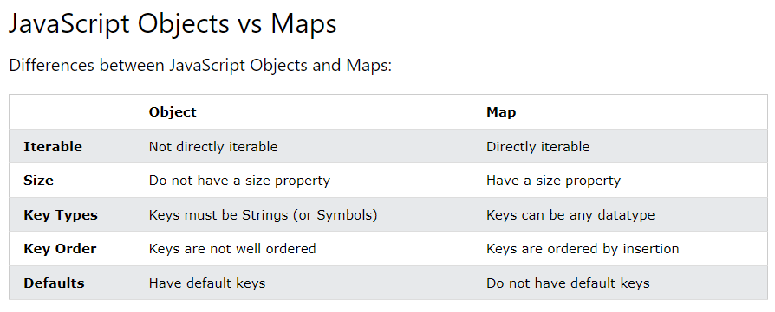

Example 01

// we can actually access any element's key using string value

const fruits = new Map([

    ["apples", 500],

    ["bananas", 300],

    ["oranges", 200]

  ]);

  fruits.forEach(element => {

    console.log(element);

});

Example 02

// .set() can be used to add new elements and update value of existing element

const arr = new Map();

arr.set("yo",3);

arr.set("hey you",31);

arr.set("there",6);

arr.set("hq",42);

arr.set("dwsx",7);

arr.set("downtown",91);

console.log("array before update");

arr.forEach(element1 => {

    console.log(element1);

});

Example 03

// update element :

arr.set("hq",88);

console.log("array after update");

arr.forEach(element1 => {

    console.log(element1);

});

Example 04

// delete element

arr.delete("yo");

console.log("array after delete");

arr.forEach(element1 => {

    console.log(element1);

});

Example 05

// array size

console.log("array size "+arr.size);

//The has() method returns true if a key exists in a Map:

console.log("array has "+arr.has("downtown"));

***Spliced method :***

Use splice method to add elements anywhere in the array. While optionally removing one or more elements from array.

var arr=["some","People","have","curly","brown","hair"];

arr.splice(2,2,"must"); //adding element at index 2 removing index 2 past element.

console.log(arr);

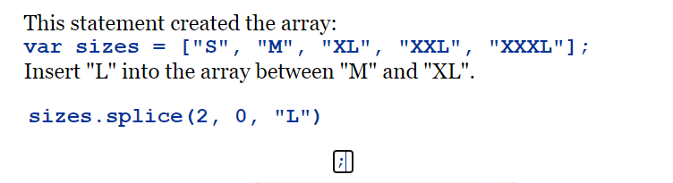

***shift method :***

var arr=["some","People","have","curly","brown","hair"];

arr.shift();  // remove first element in the array

console.log(arr);

***Unshift method :***

var arr=["some","People","have","curly","brown","hair"];

arr.splice(2,2,"must"); //adding element at index 2 removing index 2 past element.

arr.unshift("yo","man"); // add elements at the beginning of the array

console.log(arr);